**CONTACT DICTIONARY**

**LOW LEVEL DESIGN**

**Overview of Contact Dictionary:**

The purpose of Contact Dictionary is to implement the dictionary of contacts in which we store the information of all personal and business contacts. It enables the user to add, update, delete and list all the personal and business contacts. This application includes name, mobile number, email id, contact id, date of birth, emergency contact, designation, company website. In this application we can store all attributes of all personal contacts and business contacts.

**Procedure Flow:**

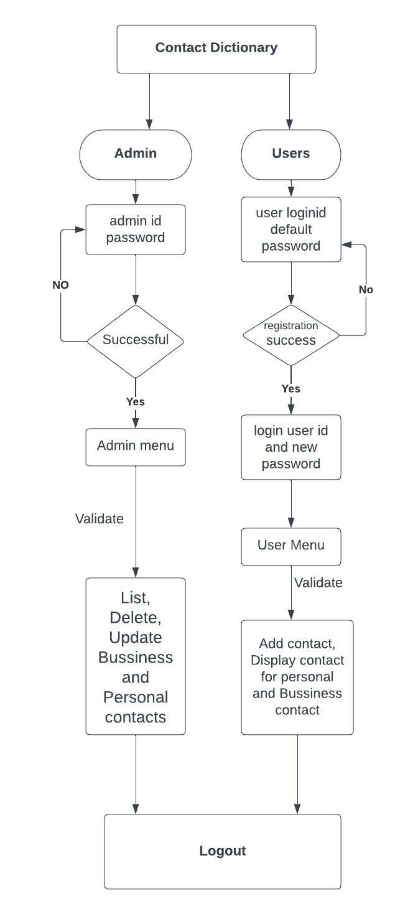

**User Registration:**

The new user will login to Contact Dictionary by using username and default password “Changeme” after successful registration the user can change the password by using the following steps

* Reset password
* Give username and new password
* New password will update successfully.
* Otherwise, it will give invalid user

**Admin login:**

The admin can login into the Contact Dictionary by using the following information.

* Login id
* Password

**Procedure Flow:  
User login:**

After successful registration of the user, the users can login to the Contact Dictionary by using user id and password. The users can view the user menu as follows

* Add contact
* Display contact

**Admin Menu:**

By using the admin credentials admin can login into the Contact Dictionary. The below information that admin should follow

* List all personal contacts
* List all business contacts
* Delete personal contacts
* Update personal contacts
* Delete personal contacts
* Update business contacts